**Server programmieren**

**Server**: socket, bind/listen, accept (socket, bind, receive, send, close), close;

**Client**: socket, bind/connect, send, receive, close;

//Server

class TimeServer {public void provideService() {int port = 8883;ServerSocket server = new ServerSocket(); server.listen(port); while(true){Socket client = server.accept(); HandleRequest hr = new HandleRequest(client); hr.start();}}}

//HandleRequest

class HandleRequest extends Thread {private Socket client; HandleRequest(Socket client) {this.client = client;} run() {String message = client.receive(); if(message == "getTime") {String result = getTime(); client.send(result); client.close();}}}

//Client

class Client {public void sendMessage() {String ipAddress='112.32.86.113'; int port = 8883; String message = "getTime"; Socket client = new Socket(); client.connect(ipAddress, port); client.send(message); String result = client.receive(); client.close(); print result;}}

**Advantages/Disadvantages of asynchronous to synchronous socket handling**

**Advantage**: Scalability, Slow consumers cannot block the server for a long time, one thread can handle multiple sockets, **Disadvantage**: Complex handling code, requires different kind of architecture, Eventloops

XDR:

struct forecast{ string weekday; int temperature; string tags<>;}

**Encode**: weekday: length “Monday” = 00 00 00 06 6D 6F 6E 64 61 79 00 00

Temperature: 00 00 00 0E

Tags: Anzahl Tags, length 1, „sunny“, length 2, dry

00 00 00 02 00 00 00 05 73 75 6E 6E 79 00 00 00 00 00 00 03 64 72 79 00

Total= alles von oben

ASN:

Forecast ::= SET{ weekday IA5String temperature Integer tags SEQUENCE OF IA5String; }

**Encode**: *weekday:* type length ohne auffüllen = 16 06 6D 6F 6E 64 61 79

*Temperature* = 02 01 0E

Tags: class + f + type, total length, type1, length1, “*sunny*”, type2, length2, “*dry*”

= 30 0C 16 05 73 75 6E 6E 79 16 03 64 72 79

Complete stream: class + f + type, total length, alles von oben

**Types**: boolean 1, integer 2, bit string 3, octet string 4, sequence h10/d16, set 11/17, IA5String 16/22

**Tag**: Class {universal 00, private 11}, f {primitive 0, constructed 1}, Number {von oben}

Disadvantages and Advantages

**ASN.1** encodes type information into the message. 1. The receiver doesn’t need to know the data description. 2. The messages contain additional overhead. **XDR** uses blocks with multiples of 4 bytes. 1. A lot of space/bandwidth is wasted with zero bits. 2. Fixed length of messages reduces the computational load. **XDR** doesn’t encode type information into messages 1. Receiver needs to know the data description. 2. The message only contains data(no meta information).

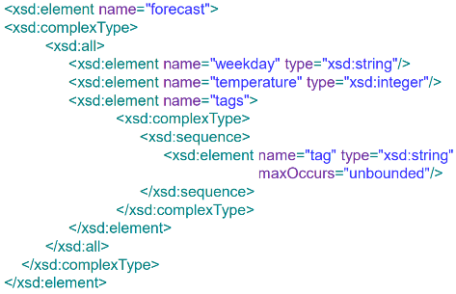XML and JSON examples

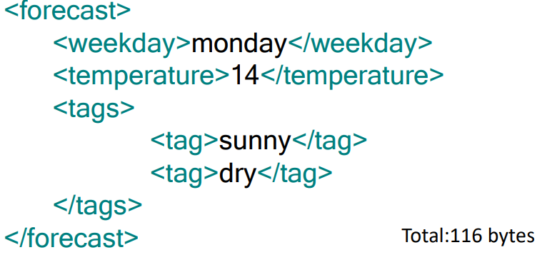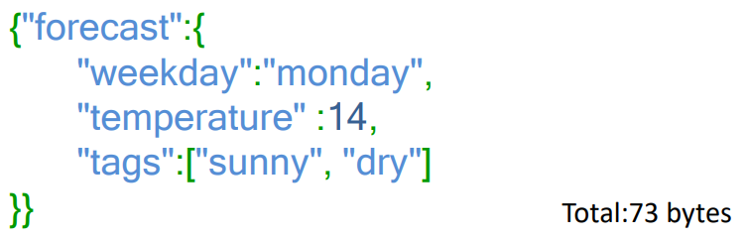

Byte = Anzahl Zeichen

Disadvantages and Advantages XML vs JSON

**XML** 1. XML has large overhead. It is slow to write and parse. 2. Format is human-readable. Intuitive hierarchical structure, easy to read, also for non-programmers. 3. XML Builders/Parsers exist in every programming language. 4.. XML is defined as standard (as well as JSON). **JSON** 1. JSON has less overhead than XML, but still more than the binary data representations. 2. Still a human-readable format, not as structured as XML. 3. JavaScript support. JSON can be directly loaded into the Browser and deserialized into objects.

Protocol Buffers

message forecast{ required string weekday =1 required int32 temperature =2 repeated string tags =3}

**Types**: Varint 0, 64-bit 1, string/byte 2, start group 3 end group 4, 32-bit 5

Field tag type (field tag + type in hexa) length value

**Encode**:

00001 010 0A 06 6D 6F 6E 64 61 79 (Monday – 0A entspricht 1010)

00010 000 10 0E (keine Länge bei int)

00011 010 1A 05 73 75 6E 6E 79

00011 010 1A 03 64 72 79 (bei tags wird die Nummer nicht erhöht)

Apache Thrift

struct Forecast{ 1: string weekday 2: i32 temperature 3: list tags }

**Type**: Boolean 1, binary string 2, byte 3, i16 4, i32 5, i64 6, double 7, string 8, list 9

**Encode:**

Wie oben, Unterschied nur bei tags.

Field tag type(4 bit) (field tag + type in hexa), (#Items, type), length1, value1,…,end

0011 1001 36 28 05 73 75 6E 6E 79

03 64 72 79 000

28 🡪 2 list items type 8 (string) 🡪 0010 1000

Disadvantages and Advantages

**Protocol Buffers** 1. Highly efficient in writing/parsing data. 2. Well documented project. 3. Versioning of data structures possible. 4. No RPC implementation. **Apache Thrift** 1. Multiple protocols to serve different purposes(binary, JSON). 2. Extensions for many programming languages. 3. RPC libraries included. 5. Versioning of data structures possible. 5. Open source project, widely used.

Variable number encoding – protobuf protocol – Für Zahlen > 255

Field tag typ (FT + typ) value

00001 000 08 D0 91 32 (=821.456)

Zahl in binär: zB 821456 = (11001000100011010000)

1. Bit (1 wenn weiteres Paket, 0 wenn fertig) + 7 Bits von hinten beginnend

D0 = **1** 1010000 91 = **1** 0010001 32 = **0** 0110010

(signedint)

Nomal: zuerst positiv (0…2,147,483,647,-1…-2,147,483,647)

ZigZag:bei negativen: 821.456*(-2)-1, positive 🡪 821.456*2

RPC (Remote Procedure Calling)

1. c → s(k1,5), s Ꝺ (k1,5), s → c(k1,5)

2. c → s(k1,7), s Ꝺ (k1,12), s → c(k1,12)

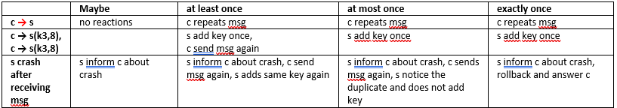

C -> s bedeutet Fehler beim senden

**Service interface in a .proto-file:**

message SearchRequest {required String attribute =1; required String value =2;} message CustomerList{repeated Customer customers =1;} message CategoryList{repeated Category categories =1;}

service AdministrationService {rpc CreateCustomer (Customer) return (Status); rpc DeleteCustomer(Customer) return (Status); rpc SearchCustomer(SearchRequest) return (CustomerList); rpc CreateCategory(Category) return (Status); rpc DeleteCategory(Category) return (Status); rpc SearchCategory(SearchRequest) return (CategoryList);}

downside of using delimiters to build/parse object properties

The values of object properties should never include one of the delimiters, If a class is changed, parsing the old classes will probably fail, Object meta information can be stored into the message → XML, Object properties can be serialized in bytes, fixed length intervals can be used → Protocol Buffers

Web services with SOAP, wsdl (focuses on processes)

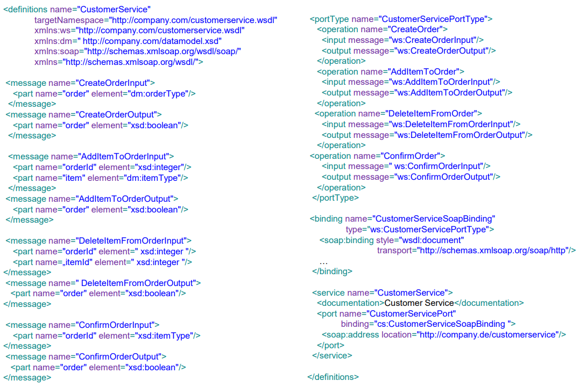





CRUD heavy Applications are a **bad** use case for RPC/SOAP: We have to define a lot of (CRUD) operations, Repeatedly, we have to define the same (CRUD) operations for different object types, We have to define a lot of messages, that contain no parameters or only one primitive, SOAP is depending on XML; large overhead for complex objects

Webservices with REST (REST focuses on resources)

* Rest verbs (GET, UPDATE, POST, DELETE)
* REST file: define paths and operations

**Resource path:**

Customer(customerId): “[http://company.com/customerservice/customers/{customerId}/](http://company.com/customerservice/customers/%7bcustomerId%7d/)”

Analog für Order, Item und Category

**Operations:**

Create Order: **POST** “<http://company.com/customerservice/orders/>”

Update Order: **PUT** “<http://company.com/customerservice/orders/>{OrderId}”

Get Order: **GET** “<http://company.com/customerservice/orders/>{OrderId}”

Delete Order: **DELETE** “<http://company.com/customerservice/orders/>{OrderId}”

Confirm Order: **PUT** “<http://company.com/customerservice/orders/>{OrderId}/confirm/”

Add Item: **POST** “<http://company.com/customerservice/orders/>{OrderId}/items/”

Delete Item: **DELETE** “<http://company.com/customerservice/orders/>{OrderId}/items/{I Id}/”

**REST** is data centric, therefore a nice Use Case for CRUD heavy applications, Resources are identified by URL, unified schema, Access always by the same operations POST, GET, PUT, DELETE, Results in clear APIs; REST is independent of data representation

DNS resolution

**DNS (iterative vs recursive)**

Bsp.: iterative: c1 → dns1(URLw1), dns1 → c1(IPr1)

recursive: dns2 → r1(URLw6), r1 → dns2(IPz2)

**DNS zone records:**

Name server 1 – 3

Mail server 1 + 2

www.itcompany.de, mobile.it…., internal.it…

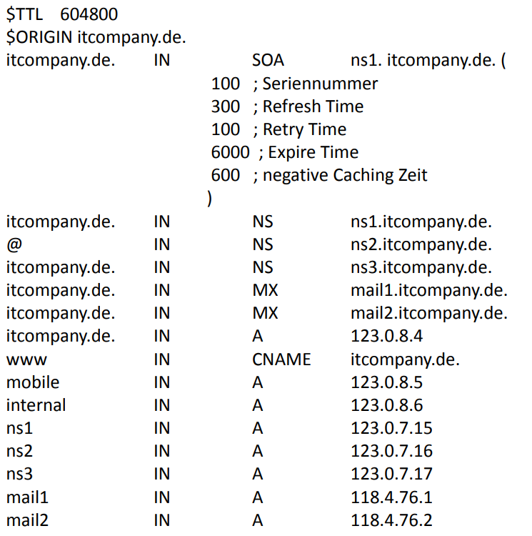

**Message queuing**

enum Durability {Persistent, InMemory} class Producer {public void enqueue(byte[] message) {...}} class Consumer {public byte[] dequeue() {...}} class ChannelFactory { public void setHost(String broker) public void queueDeclare(String queuename, Durability durability) Producer newProducer(String queuename) Consumer newConsumer(String queuename)}

//Client

ChannelFactory cf = new ChannelFactory(); Producer producer; Consumer consumer; public void init(){cf.setHost("broker.tum.de"); cf.queueDeclare("request_queue", Durability.Persistent); cf.queueDeclare("response_queue", Durability.Persistent); producer = cf.newProducer("request_queue"); consumer = cf.newConsumer("response_queue");} public void send(byte[] msg){producer.enqueue(msg);} public byte[] receive(){byte[] response = consumer.d

equeue(); System.out.println!("received message back" + response.toString()); return response;}

//Server

ChannelFactory cf = new ChannelFactory() Producer producer; Consumer consumer; public void init(){cf.setHost("broker.tum.de") cf.queueDeclare("request_queue", Durability.Persistent); cf.queueDeclare("response_queue", Durability.Persistent); producer = cf.newProducer("response_queue"); consumer = cf.newConsumer("request_queue");} public void run(){while(true) {byte[] request = consumer.dequeue(); println!("received msg" + request) try{Database.store(request); producer.enqueue("ACK".toBytes())}catch(Exception e){producer.enqueue("ERROR".toBytes())}}}

**Messaging – R/R with queued transactions**

1. c1(10,25.7) 2. c1(11,23.3) Client crashes during Transaction T X1 3. c1(25,21.6) Client crashes after Transaction T X1 4. c1(17,23.9) Client crashes after Transaction T X2 5. c1(4,18.8) Client crashes after Transaction T X3

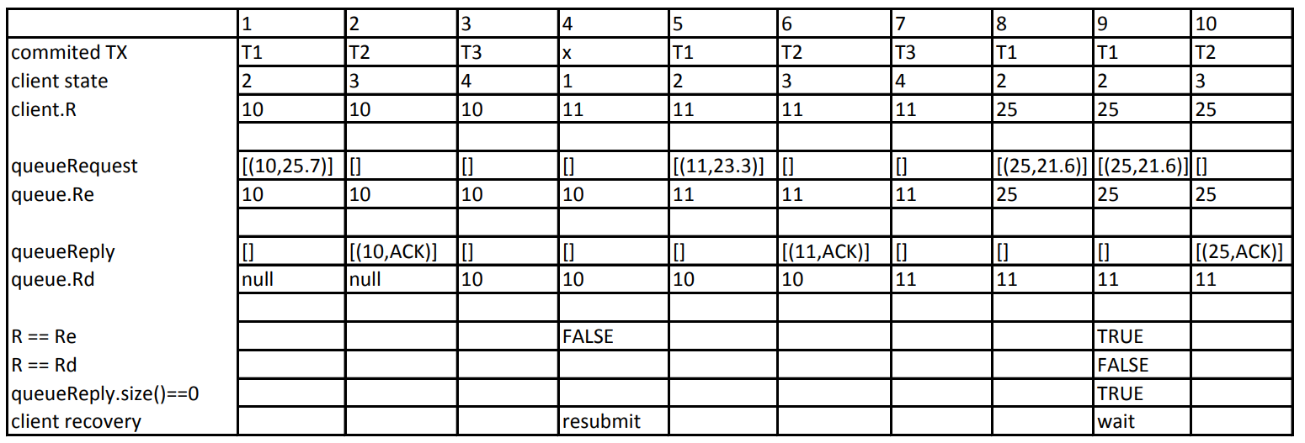

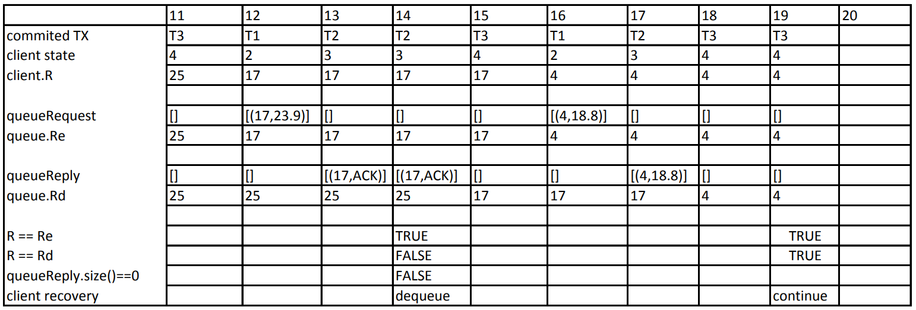

Queuing theory example

Customers arrive at a theatre ticket counter in a Poisson fashion at the rate of 4 per hour. The time to serve a customer is distributed exponentially with mean 10 minutes. Calculate the following values:

**arrival rate:** λ = 4/h = 1/15min

**service rate:** µ = 1/10min

ρ = λ/µ = 10/15 = 2/3

N = λ/(µ - λ) = 2 (mean number of customers in the system)

Tsys = 1/(µ - λ) = 30min (mean time spent in the system, only if ρ < 1)

Tqueue = Tsys – x = 30min – 10 min = 20min

Pn = ρn(1 - ρ)

P0 = (1 - ρ) = 1/3 (probability that a customer arrives to find the ticket counter empty)

**Utilization**: λ * µ

Queuing theory - Parking space

Consider the ticket counter again. A parking space should be build in front of the ticket counter such that the customers can park their cars while waiting for the tickets. The requirement is that 90% of the time, the customers should find parking.

general formula for P(k ≤ n) 🡪 **P(k ≤ n) = 1−ρn+1**

general formula for n 🡪 **n = ln(1−P(k≤n))/ln(ρ) − 1**

Queuing theory – Cost evaluation

determine cost function

bsp. : Cs = 10 µ/h, employee waiting in the system (queue and also getting served) is 50/h, arrival rate λ = 8/h

$$C_{Employee}\left(µ\right)=N ×\frac{50}{h}= \frac{λ}{µ-λ}×\frac{50}{h}= \frac{400/h^{2}}{\left(µ-8/h\right)}$$

Queuing Theory - Traffic flows

Arrival and departure rate

Is a queue stable?

service time < arrival time, µ < λ

**Achtung**: wenn Schleife zwischen Nodes dann Gleichungssystem

Two Phase Commit Protocol (2PC)

- 2PC execution (Vote Phase, Completion Phase)

- Coping with failures

**- Timeouts** are used to cope with failures

- Beispiele für Timeout-Aktionen, die keine Rücksprache mit anderen Parteien erfordern

- Coordinator aborts TX when it timeouts in initial or wait state

- Coordinator retransmits commit/abort message to participants when it timeouts in commit/abort state

- Participant aborts TX when it timeouts in initial state

- when a participant timeouts in the prepared state, consultation is required

- The period from when a participant has voted to commit to the moment it knows the global decision, is called **uncertainty period**

- Uncertain participant is blocked, until it becomes certain

**- It cannot unilaterally abort because it cannot revoke its vote**

**- It can also not unilaterally commit because the global decision may be to abort**

- It can try to contact other participants to find one which is certain (that either voted abort or that already knows the global decision)

- If it can only contact uncertain participants, it is blocked (reason may be communication failure or failure of all other sites)

Publish/subscribe

Publish/subscribe – content-based routing

Bsp: {p2,b2,b1,{b4,s3}||{b3,s4}} → s3,s4

Publish/subscribe - composite subscriptions (CS) 🡪 with AND and OR

Advantage with **AND** expression (…)

topic based routing

Examples:

p2 connects to b2 and advertises sports

[l1,=,sports][l2,=,∗][n,=,∗]

* + s3 connects to b3 and subscribes to football and tennis

[l1,=,sports][l2,=, football] AND [l1,=,sports][l2,=,tennis]

* + Publisher p3 publishes news n2 under politics

**Message**:[l1, politics][l2,**null**][n,n2]

**Path**:{p3,b4,b1,b0,s2} → s2

State machine verification

Draw message exchanges between two processes

Draw the composition of the state-machine until the end or deadlock from a given combination

t5 = (s4,true,a2,s5), t6 = (s5,true, ?m5,s6), t7 = (s6,true,a3,s7), t’5 = (s’4 ,true,a2,s’5 ) t’6 = (s’5 ,true,a3,s 0 6 ) t’7 = (s’6 ,true,!m5,s’7 )

